**“Analyzing the effects of memantine on trisomic mice”**

Caleb Richards, Yuqin Bao, Karen Lohman, Jacqueline Garcia

**Introduction**

The genetic disorder Down syndrome (DS) is the reported as the most common cause of intellectual disability worldwide. The worldwide DS birth rate is estimated at one in 1000 live births (Higuera et al. 2015). The syndrome is typically caused by trisomy of the 21st chromosome, a condition in which an additional full or partial copy of a chromosome is inherited by the offspring from the parents. This is caused by an incomplete chromosome division during meiosis in the gametes of one parent such that an undivided chromosome pair from one parent is joined with the chromosome from the other, producing three full or partial chromosome copies.

Responsible for a wide range of physical disabilities and developmental delays, Down syndrome individuals typically show a learning disability. This cognitive disability has been hypothesized to occur due to an ‘overexpression’ of genes found on the long arm of the 21st chromosome, causing excessive protein levels and neural degeneration due to protein plaques similar to those found in alzheimer’s patients (Masters et al. 1985). With advances in medical treatment extending the average life expectancy of these individuals, more emphasis has been placed on developing pharmaceutical therapies to improve cognitive function and lessen the effects of the syndrome. One drug that has been found to have success in treating poor cognitive function by blocking neurotransmitter receptor activity for diseases with cognitive deterioration is memantine (Higuera et al. 2015). A group of researchers have studied the effect of memantine on improving the learning ability of trisomic mice in experimental trials. In the study by Gardiner et. al., investigating the effectiveness of the drug memantine on repairing learning pathways produced the protein expression dataset analyzed for this project.

**Methods: Experimental Design**

The Gardiner study used a total of 72 mice divided between nested experimental and control groups. To simplify the dataset for our biological question and statistical analysis, we ignored the control data produced by the study’s ‘healthy’ control mice and focused on the thirty-four ‘disease state’ trisomic mice. The trisomic mice were divided into two groups to receive either the learning recovery shock treatment or control, and those two groups were further subdivided into drug treatment or control groups, such that four total experimental groups were produced: nine mice designated shock treatment-memantine treatment, and nine mice as shock treatment-saline control; nine mice shock control-memantine treatment, and seven mice as shock control-saline control. Tissue was collected from the cerebral cortex to isolate protein lysates and generate protein expression data. The protein expression level measurements were repeated 15 times per protein per mouse. A total of 77 proteins associated with cognitive deficits or from a family known to be associated with cognitive deficits were investigated in this study. The protein-expression data was collected by the School of Medicine at the University of Chicago and was made available through the UCI Machine Learning Repository.

**Methods: Learning Recovery Experiment**

To assess learning ability, each mouse was selected to receive one of two types of treatment, either CS (context-shock) or SC (shock-context). CS treated mice were introduced to a cage and allowed to explore the space freely then given a small electric shock. SC treated mice were given an electric shock prior to being allowed to explore the cage they were in. Each mouse was then given either a treatment of the drug memantine or a saline solution control (Figure 1). After administration of the drug treatment, the response of each mouse was measured upon re-introduction to the cage. If the mice feared the cage and remained still as a response to the fear, the mice were assumed to have successfully learned how to respond to the cage. Mice that exhibited no signs of fear were assumed to have not learned how to respond to the threat and thus failed the test, showing a sustained cognitive defect. A binary learning outcome in response to the shock-context/context-shock trial was recorded for each mouse, as well as a binary designation of memantine treatment or saline control.

*Higuera et al. Figure 1. Experimental Design and Classification of Mice Groups*

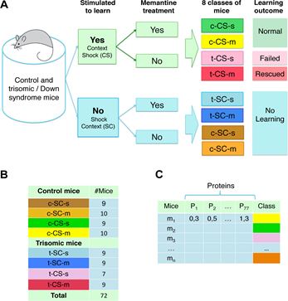

***(A)*** *Mice were subdivided into eight groups for the original study based on control or trisomy, treatment with memantine or treatment with saline control, and exposure to learning stimulation (CS) or learning control (SC).* ***(B)*** *Number of mice assigned to each group.* ***(C)*** *Data format available on UCI Learning Repository (Higuera et al.). Data from non-disease state (control) mice was ignored for the purposes of our analysis.*

**Statistical Analysis:**

Our project is an investigation into whether the memantine treatment and a rescued learning ability predicts certain protein expression levels for the mice. To test this, we created linear regression models for each protein based on the following formula which we call the full model,

$$y_{i}=β_{0}+β_{1}x_{1}+β_{2}x_{2}$$

where $y_{i}$ represents the mean expression level of the *ith* protein for a given mouse, $x_{1}$ is a binary predictor of whether a mouse received memantine treatment, and $x_{2}$ is a binary predictor for whether the mouse exhibited rescued learning abilities in the experiment. The $β_{i}$ are coefficients given by the linear regression models. Because we were using the mean of the protein measurements, we checked the protein variance level, and found that the proteins had small variation between mice and the variance had an approximately normal distribution. Under our null hypothesis, $β_{i}$ = 0 means that drug treatment and learning help predict a change in protein expression. For each model, a p-value was computed for $β_{1}$ and $β_{2}$ to test if they are associated with a statistically significant change in protein expression.

An initial model was created using this expression for each of the 77 proteins and 30 were found to fit the data well at significance level = 0.01. For the 30 significant initial proteins, 17 were modeled well by both predictors with p-values of < 0.01 for each predictor variable; 11 had significant p-values for only the learning outcome, and 2 had significant p-values for only the drug treatment. Two proteins were found to be an exact duplicate of each other for each recorded protein level; one of the duplicates was removed from further analysis so that we only counted the total number unique, biologically independent protein markers that were significant for our final results. The duplicate result is included in Table 1. To produce a more robust statistical design we have included a multiple testing correction, the application of Bonferroni procedure, which is expected to produce conservative corrected p-values. With this correction we changed our significance level from 0.01 to 0.00013 by dividing 𝛼/*m* where *m* is our sample size of 76 unique proteins. For the proteins that had a p-value greater than 0.01 for the drug treatment predictor and a p-value less than 0.01 for the learning outcome predictor, we reduced the model to only include the learning outcome predictor. According to our new reduced model

$$y_{i}=β_{0}+β_{2}x_{2}$$

we found that 5 of the 11 proteins that were fit to the new model still had statistically significant p-values while the other 6 did not. We discarded the 6 results for the proteins where the new model failed to maintain significance, so as to only keep the most important proteins in our final analysis. This left us with 21 proteins with significant expression changes that were predicted well by either the reduced or full model.

During our analysis the results from our reduced model indicated that the one-term model would be a more appropriate predictor for the expression level of all proteins. This is likely because the ability of an individual to have recovered learning as an outcome is dependent on whether or not the mice were treated with memantine. However, when we attempted to fit our reduced model to each of the significant proteins, we discovered that 8 results that had significant p-values in the full model were not found to be significant in the reduced model. Ultimately we kept our original analysis that found 16 unique proteins that were predicted well by the full model and the 5 proteins that were still predicted well using the reduced model. Using the Bonferroni correction the number of significant, unique proteins was reduced from 21 to 10.

**Results:**

|  |  |  |  |  |  |
| --- | --- | --- | --- | --- | --- |
| **Significant Protein** | **p-value** | **Significant Protein** | **p-value** | **Corrected Significant Proteins** | **Corrected p-values** |
| DyRK1A_N | 2.48E-05 (reduced) | P38_N | 0.000137213 | DYRK1A_N | 2.48E-05 |
| ITSN1_N | 0.001110403 (reduced) | pMTOR_N | 0.000212035 | pERK_N | 5.73E-05 |
| pERK_N | 5.723E-0.5 (reduced) | NR2B_N | 0.00589854 | BRAF_N | 1.85E-05 |
| pJNK_N | 0.008873294 (reduced) | pGSK3B_N | 0.001921105 | pNR2A_N | 9.60E-05 |
| BRAF_N | 1.85E-05 (reduced) | ARC_N | 3.92E-09 | ARC_N | 3.92E-09 |
| pBRAF_N | 0.006578899 | pS6_N | 3.92E-09 | pS6_N | 3.92E-09 |
| pNR2A_N | 9.60E-05 | ERBB4_N | 2.89E-05 | ERBB4_N | 2.89E-05 |
| pNR2B_N | 0.006817015 | IL1B_N | 0.003188526 | SNCA_N | 1.31E-07 |
| AKT_N | 6.70E-05 | SNCA_N | 1.31E-07 | Ubiquitin_N | 3.05E-06 |
| CAMKII_N | 0.001746609 | Ubiquitin_N | 3.05E-06 | AKT_N | 6.70E-05 |
| SOD1_N | 0.000194224 | CaNA_N | 8.88E-06 | CaNA_N | 8.88E-06 |

*Table 1: Table containing the significant proteins located out of the 77 proteins analyzed along with their associated p-value*s. *Boxes highlighted in yellow are identical for each mouse. p-values noted as (reduced) are from the reduced model. The last two columns are proteins that were still significant after a Bonferroni correction to our significance level (𝛼 = 0.01, m* ***=*** *76).*

**Discussion:**

Our analysis shows that for the reduced models, having an increased learning ability is associated with an average change in five proteins that we tested, where the average change is given in Table 2. For the full model, at least one of our predictors is associated with an average change in 7 of the proteins that we tested. For instance, for the protein “DYRK1A_N” we reject the null hypothesis in favor of the alternative that a successful learning outcome is estimated to be associated with a change in the protein expression level. We may also make conclusions about the full model, but they are less absolute. We claim that given a p-value of 0.00019, we reject the null hypothesis in favor of the alternative that at least one of the predictor variables (learning outcome or drug treatment) are estimated to be associated with a change in the average protein expression level for the protein “SOD1_N”.

In addition to this, we may also form 95% confidence intervals around each coefficient from the linear models. We will give an example of our interpretation for the confidence interval for the coefficient for learning outcome given the protein “DYRK1A_N”. With 95% confidence, whether or not learning ability was rescued is estimated to be associated with an increase in the mean protein expression of “DYRK1A_N” between 0.1355 and 0.3267. Likewise for the full model we may say that with 95% confidence, whether or not a mouse was given the memantine treatment will be associated with a decrease in the mean protein expression level of “pJNK_N” between 0.013 and 0.0833, holding the indicator variable if the mouse exhibited rescued result in learning ability the same with no change. Bounds for confidence intervals are given in Table 2.

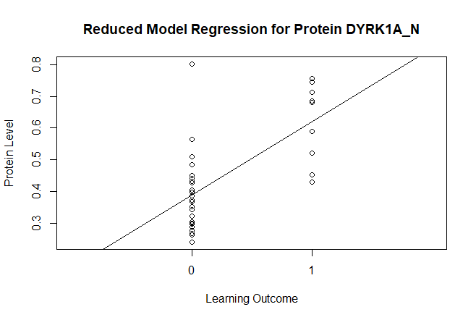

*Figure 2: Reduced Model Regression for protein data DYRK1A_N fitted with regression line. Adjusted R2=0.4133*

From these results, we predict that memantine treatment and learning outcome are associated with many proteins that were measured in the mice. The level of association varies for each protein, and even though learning outcome is dependent on receiving the memantine drug treatment, some linear regression models better predict mean protein expression better when both predictors are included in the model. In other instances, learning outcome is sufficient to predict a change in mean protein expression, as shown in Table 2.

|  |  |  |  |  |  |  |
| --- | --- | --- | --- | --- | --- | --- |
| Protein | Drug Treatment  ($β_{1}$) | Drug Treatment 95% C.I. | | Learning Outcome  ($β_{2}$) | Learning Outcome 95% C.I. | |
| DYRK1A_N | n/a | n/a | n/a | 0.2311 | 0.1355 | 0.3267 |
| ITSN1_N | n/a | n/a | n/a | 0.1814 | 0.0783 | 0.2846 |
| pERK_N | n/a | n/a | n/a | 0.3476 | 0.1948 | 0.5004 |
| pJNK_N | n/a | n/a | n/a | -0.0481 | -0.0833 | -0.013 |
| BRAF_N | n/a | n/a | n/a | 0.2056 | 0.1222 | 0.2889 |
| pBRAF_N | 0.0245 | 0.0083 | 0.0407 | -0.0271 | -0.0454 | -0.0087 |
| pNR2A_N | 0.1771 | 0.0762 | 0.2781 | -0.2766 | -0.3909 | -0.1624 |
| pNR2B_N | 0.2327 | 0.078 | 0.3873 | -0.2574 | -0.4324 | -0.0825 |
| AKT_N | 0.0947 | 0.0321 | 0.1573 | -0.1789 | -0.2497 | -0.1082 |
| CAMKII_N | 0.0511 | 0.0159 | 0.0864 | -0.0752 | -0.115 | -0.0353 |
| SOD1_N | 0.2887 | 0.0903 | 0.4871 | -0.5244 | -0.7489 | -0.2999 |
| P38_N | 0.12 | 0.061 | 0.179 | -0.1472 | -0.2139 | -0.0804 |
| pMTOR_N | 0.1876 | 0.0949 | 0.2803 | -0.2191 | -0.324 | -0.1143 |
| NR2B_N | 0.1009 | 0.0319 | 0.1698 | -0.1215 | -0.1995 | -0.0435 |
| pGSK3B_N | -0.0183 | -0.0283 | -0.0083 | 0.0173 | 0.006 | 0.0286 |
| ARC_N | 0.0215 | 0.0152 | 0.0278 | -0.0291 | -0.0362 | -0.022 |
| ERBB4_N | 0.0139 | 0.0067 | 0.0211 | -0.0213 | -0.0294 | -0.0132 |
| IL1B_N | 0.0757 | 0.0317 | 0.1198 | -0.0741 | -0.1239 | -0.0243 |
| SNCA_N | 0.0213 | 0.0118 | 0.0309 | -0.0392 | -0.0499 | -0.0284 |
| Ubiquitin_N | 0.1747 | 0.08 | 0.2694 | -0.3291 | -0.4362 | -0.222 |
| CaNA_N | -0.3299 | -0.5118 | -0.148 | 0.5922 | 0.3864 | 0.798 |

*Table 2: Proteins with their corresponding model coefficients and 95% confidence interval. Protein pS6_N has been removed because it is identical to ARC_N.*

**Conclusions:**

We observed a significant decrease in the expression of several of the tested proteins in the mice that received both the drug treatment and the learning restoration treatment. Many of the proteins tested are from the same family; these proteins were selected because they were known to be abnormal in humans and mice with alzheimer’s disease, therefore it is reasonable to have a relatively high number of significant results. The significance is consistent with previous research linking proteins isolated known to cause extensive plaque formations in both individuals with Alzheimer’s or Down syndrome which have been documented to cause a decrease in cognitive function in alzheimer's patients (Masters et al. 1985). For patients with Alzheimer’s, the pharmaceutical treatment memantine has been shown to have success restoring cognitive abilities in moderate alzheimer’s disease (Olivares et al. 2012). The overall of the original research study is to investigate whether memantine treatment could be expected to restore cognitive ability in trisomic patients, however, in order to draw inference to the larger patient population, the study would have to incorporate more data to improve reliability.

A major caveat to this study is the dependent biological interaction between the learning outcome of the mouse and whether or not it received the drug treatment. This an artefact of the experimental design of the previous work. Another caveat is the binary learning outcome of the shock/shock context learning recovery experimental design. A potentially more meaningful outcome could be produced by using a different continuous scoring scheme to measure the response of rescued learning ability. The caveats could be resolved by a change in study design. We propose repeating the experiment using a time trial maze design to measure improved learning ability, where the mice are allowed to solve a maze and their time is recorded for repeated trials.

**Supplementary Figure:**

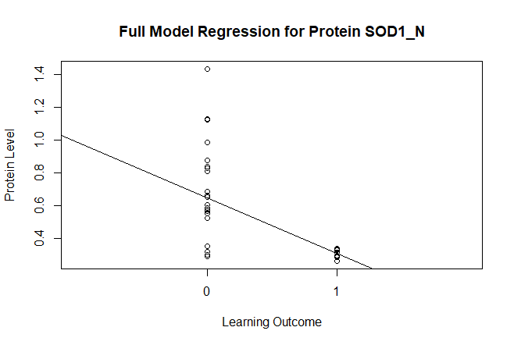

*Figure 3: Full Model Regression for protein data SOD1_N fitted with regression line.*

**Citations**

Ahmed MM, Dhanasekaran AR, Block A, Tong S, Costa ACS, et al. (2015) Protein Dynamics Associated with Failed and Rescued Learning in the Ts65Dn Mouse Model of Down Syndrome. PLOS ONE 10(3): e0119491. <https://doi.org/10.1371/journal.pone.0119491>

Higuera C, Gardiner KJ, Cios KJ. 2015. Self-Organizing Feature Maps Identify Proteins Critical to Learning in a Mouse Model of Down Syndrome. PLOS ONE 10(6): e0129126. <https://doi.org/10.1371/journal.pone.0129126>

Masters, CL, Weinman, NA, Multhaup, G, McDonald, BL, Beyreuther, K. 1985. Amyloid plaque core protein in Alzheimer disease and Down syndrome. Proceedings of the National Academy of Sciences. 82 (12) 4245-4249; DOI:10.1073/pnas.82.12.4245

Olivares D, Deshpande VK, Shi Y, Lahiri DK, Greig NH, Rogers JT, et al. N-methyl D-aspartate (NMDA) receptor antagonists and memantine treatment for Alzheimer’s disease, vascular dementia and Parkinson's disease. Curr Alzheimer Res. 2012;9(6):746–58. Pmid:21875407